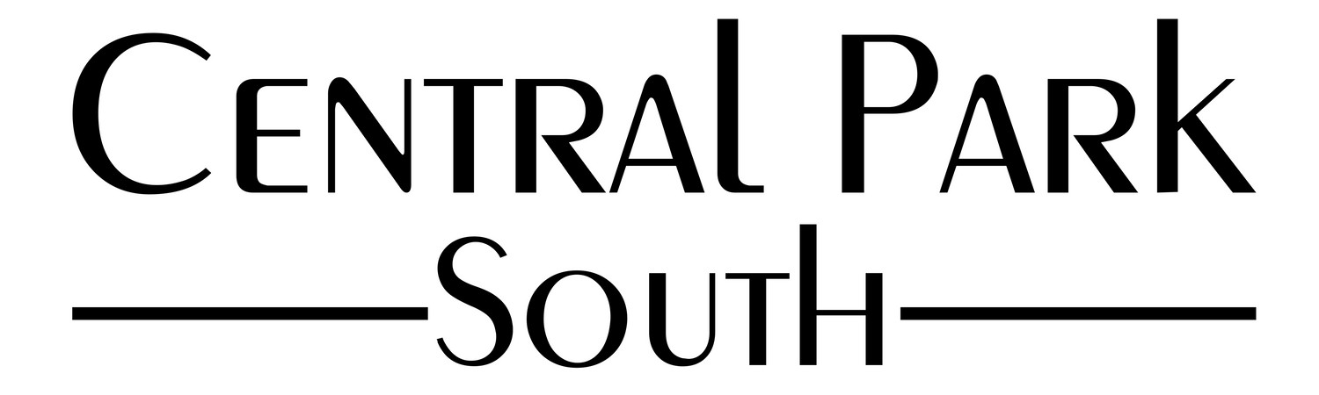

Central Park South HOA Meeting

Tuesday, May 21, 2024

In person Meeting

7:00p.m- 8:00p.m

**Attendance**

1. Julie Lattimore, President
2. Ted Abramowicz
3. Hind Kazbour - Secretary
4. Kenny Karnib

**Not in Attendance**

1. Pete Seitz
2. Stephanie Laroo- Treasurer
3. Arthur L. Jackson - Vice President, Finance

New Officer changes and votes were unanimous.

Board Acceptance of former Board Member **Clarence Baker III** effective May 21, 2024.

**Changes in officer roles effective immediately**

1. Ted Abramowicz - Vice President / Compliance
2. Clarence J Baker III - Treasurer / VP Finance
3. Hind Kazbour - Secretary
4. Stephanie Laroo - Contract Procurement
5. Arthur Jackson III - Board of Director
6. Kenny Karnib - Board of Director
7. Julie Lattimore - President

Pete Seitz has fulfilled his term and due to lack of connection, has ben unanimously voted off the HOA Board for 2024

**Meeting Topics**

* Landscape Report- Members discussed Non-Compliance 1st and 2nd notices. Ted will be following up with Non compliant properties and an attorney for protocol.
* Follow up with Rigero Pond Bio-Health maintenance.
* Members discussed removing Park Creek old tree stumps and Debris from behind the Central Park South residential home.
* Eroded Sewage on Empire State
* Willow Tree Evaluation

**Unfinished Business**

* Removing and trimming trees - Perfectly Neat will trim all common area trees 7 ft from the ground and remove 3 large dead/broken trees in pond area by Brooklyn
* Entrance Signs- gather quotes and styles
* Fountains